**Design Template**

|  |
| --- |
| Hobby Software Consulting |
| Software Project Template |
| C188 – Performance Assessment |

|  |
| --- |
| Kristina Hobby  7-10-2023  [Version 1.1] |

# KC

Contents

A. Introduction 3

A.1. Purpose Statement 3

A.2. Overview of the Problem 3

A.3. Goals and Objectives 3

A.4. Prerequisites 3

A.5. Scope 3

A.6. Environment 3

B. Requirements 4

B.1. Business Requirements 4

B.2. User Requirements 4

B.3. Functional Requirements 4

B.4. NonFunctional Requirements 4

C. Software Development Methodology 5

C.1. Advantages of the Waterfall Method 5

C.2. Disadvantages of the Waterfall Method 5

C.3. Advantages of Scrum 5

C.4. Disadvantages of Scrum 5

C.5. Best suited 5

D. Design 6

D.1. Storyboard of Server Split 6

D.2. Diagram Login Process 7

D.3. GUI Login 8

E. Testing 9

E.1. Compatibility, Scalability, and Usability 9

E.1.1. OS/Browser Compatibility 9

E.1.2. Scalability 9

E.1.3. Usability/Functionality 10

F. Sources 12

# Introduction

Hobby Software Consulting is proposing this CRM solution to American Video Game Company. Below, you will find the overall design, details, processes, methods, requirements and testing for this solution.

# A.1. PUrpose Statement

The purpose of this document is to lay out the design and requirements for a new CRM solution for AVGC.

# A.2. Overview of THE PROBLEM

AVGC needs to scale up to accommodate its 42 percent growth in the last two years. AVGC’s current system is outdated for this level of growth. Processes are not the same across the business and teams. AVGC’s current servers and systems are not capable of sustaining the current concurrent users or projected future growth.

# A.3. Goals and Objectives

Here are the goals and objectives of our CRM solution:

Enhance scalability for current and future growth

Improve efficiency

Increase useability and be intuitive

Work with the company’s current systems as well as provide new hosting solutions

# A.4. Prerequisites

|  |  |  |  |
| --- | --- | --- | --- |
| Number | Prerequisite | Description | Completion Date |
| 1 | Acquire new Cloud-Native Platform | The new servers will need to be acquired prior to transfer/split of data. | Prior to beginning transfer |
| 2 | Data Collecting | Data collection and admin access are required to determine server requirements. | 1 week prior to step 1 |
|  |  |  |  |
|  |  |  |  |

# A.5. Scope

These items are in scope:

* Scalability for 2000 users log in with 500 during peak times
* Enable soft and hard deletes
* Update hosting
* Update OS and Browsers
* Maintain versions of records with auditing, workflow, and roll-back

These items are out of scope and may be the focus of a future solution:

* Hardware of in-house servers - hardware of current in-house systems will not be upgraded at this time

# A.6. Environment

The upgrade will be operational in the latest systems:

* latest Chrome and Chromium
* latest Firefox
* I.E 9 and above
* Safari 6.0 and above
* mobile & tablet
* iOS7 Safari
* iOS7 Third Party Browsers (Chrome and Firefox)
* Android 4.0 Chrome
* Cloud-Native Storage with following requirements:
  + Allow for automatic scaling of hardware to support higher number of concurrent users
  + Meet all SLA’s
  + Upgrades available on demand and can be declined
  + Customizable to the AVGC’s specifications
  + Cloud services are not vulnerable to regional outages with superior up-time
  + 24/7 support
  + Maintenance included
  + Testing environments available
* Current onsite storage – data backup only

# Requirements

These are the five requirements that will be discussed below:

1. Hosting – Adding a Cloud – Native platform with the current servers acting as backup for data only
2. Soft and hard delete – keeping outdated records in the background without deleting and restricting data access to specific roles and or permissions.
3. Users – System must support 2000 users with 500 concurrent
4. OS and Browser support - operating systems and browsers will be updated and tested for compatibility.
5. Maintain versions of records with auditing, workflow, and roll-back

# Business Requirements

The business must maintain versions of records with auding, workflow, and roll-back. For this purpose the current onsite server system will act as data backup only. All data needing backup will be archived at this location, allowing for access or roll-backs when need be.

# User Requirements

The system needs to support a minimum of 2000 users with a peak of 500 logging in during peak times. We can accomplish this with the utilization of hosting services. Upgrading the server systems will increase scalability for the current usage and the expected growth. See the following proposal on hosting.

Hosting in-house has had benefits previously for AVGC. However, AVGC has outgrown its current system, causing issues both for daily workflow and users. Adding a cloud-native platform would enable the company to scale horizontally and vertically. These servers have higher CPU/RAM and will allow more users access during peak times. In the following sections, our stress test demonstrates the scalability of this implementation.

# Functional Requirements

The system must be compatible with the latest operating systems. Our CRM will update the operating systems to support the latest software upgrades for the client’s products, including the software required to connect to the cloud-native servers. This upgrade will allow for expected user connectivity.

The system must have a robust security. Our recommendation would be to use hard and soft deletes. These deletes will allow individual users to view information without integrity loss or confidentiality by using the principle of least privilege.

# NonFunctional Requirements

Adding a cloud native storage system will improve speed and capability, allowing more users access.

Updating operating systems and browsers will improve access, speed, and security.

Implementing soft deletes will prevent data loss, while hard deletes will increase security through the principle of least privilege.

# SOFTWARE DEVELOPMENT METHODOLOGY

Here we will compare Waterfall with Scrum.

# Advantages of the waterfall method

* Ease of use - no prior knowledge/training needed, easy to manage and control throughout each phase
* Linear flow - each phase has a start and end point, decreasing chances of falling behind on deadlines
* Documentation in each phase - leaving a paper trail for changes in the future and making sure the plans are outlined prior to start

EBY, K. (2017, February 15)

# disAdvantages of the waterfall method

* Change is not easy – going back to previous phases is not in the process. It is difficult, if not impossible, to make changes after a phase has ended
* Multiple phases prior to beginning implementing solutions
* Accuracy of information - reliably gathering information from customers for the the best solution is not completely accurate. Change of mind or not knowing what they really want can cause problems designing the solution

EBY, K. (2017, February 15)

# Advantages of Scrum

* Highly transparent – daily check-ins and meetings allow the whole team to know how everything is going within the project
  + Allows issues to be easily found
* Changes are easy to implement – short-sprints allow for changes to be added to a future short-sprint
* Team accountability – teams decide together what is manageable in each short-sprint, team members collaborate, help each other, and work independently

EBY, K. (2017, February 15)

# disAdvantages of scrum

* High risk of scope creep – No set end date and no locking out of phases scope creep is possible at many points
* Training and experience – A level of experience in “scrum roles”, previous training, and experience is needed
  + Team members must have experience in having responsibilities without defined roles
* The team must also be dedicated to the daily meetings
* Tasks defining – tasks and short sprints must be properly defined to continue on a timely project, planning can be difficult and be lengthy

EBY, K. (2017, February 15)

# best SUITED

Hobby Software Consulting agrees that Waterfall is the correct methodology for AVGC. Each phase has a clear start and end point. Because of this, the chance of scope creep is far less than with Scrum. After the onsite servers become data only and the cloud-native system is implemented, there will be no ability to switch between systems. This is clear with Waterfall. Also, the ease of use of Waterfall with AVGC’S outline for their requirements will allow for a project with clear start and end points, less chance of going outside of scope, and reduced time and cost.

# Design

Here our company shows the split with the dual server system. Then, the flowchart shows the login and access for the company for both server locations compared to the user side. Last, the interface available to both servers is shown as a graphical user interface.

# Storyboard of Server split

Split from current servers to current and cloud-native:

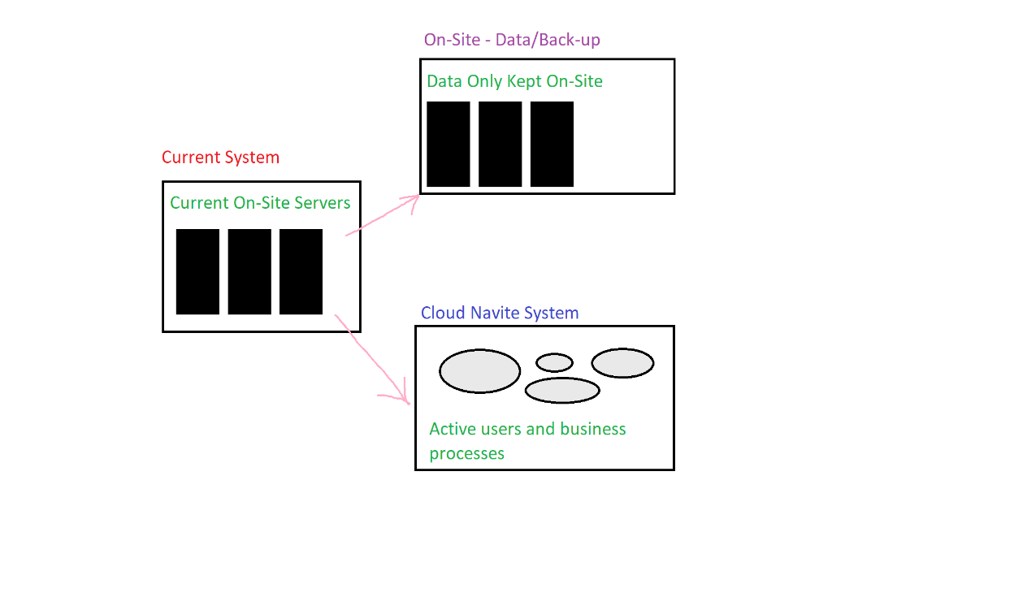

Figure 1: Sample Storyboard

# Diagram Login process

This diagram shows the login flow for users and company side admin.

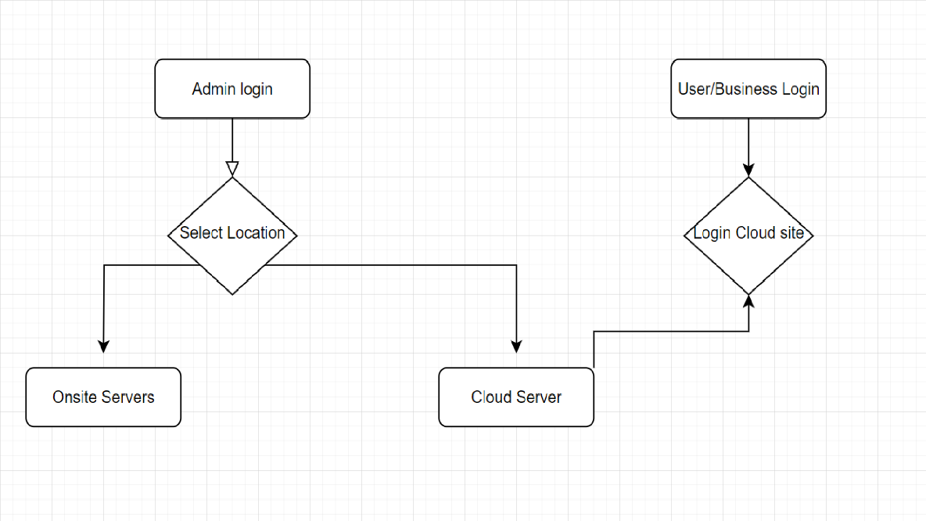

Figure 2: Sample Database

# GUI Login

Design for login:

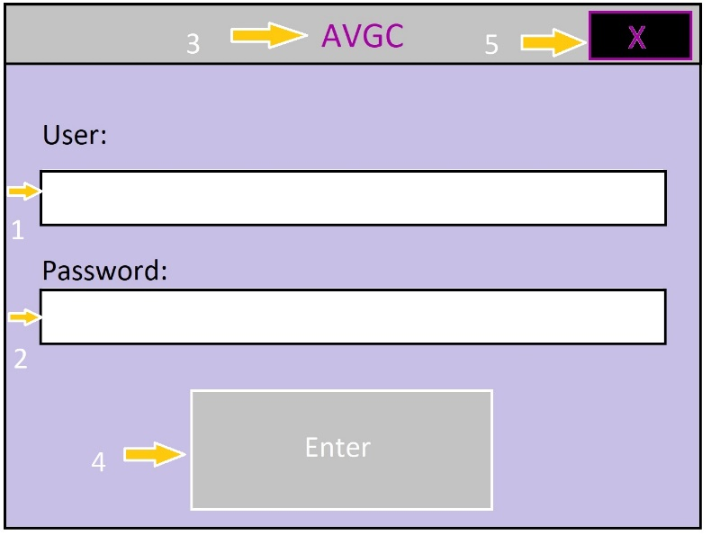

Figure 3: Sample GUI Mock-up

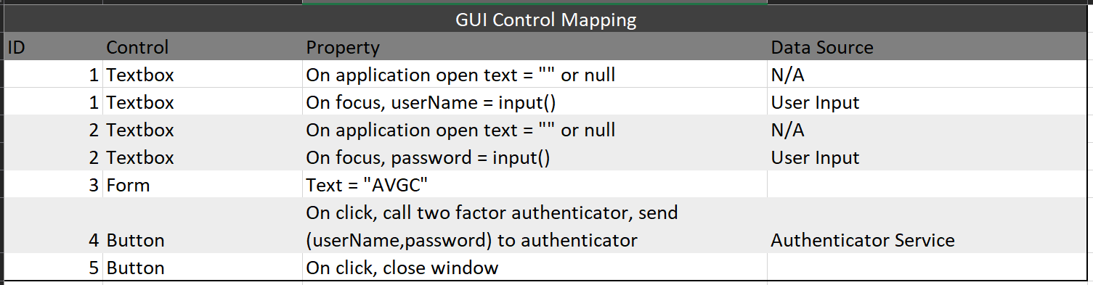

# Testing

These tests will check compatibility, scalability, and usability.

# Testing OS/Browser compatibility, Scalability, and usability

This test will check compatibility within the browsers and operating systems listed. This will require testing each browser in each operating system to confirm that all possibilities are functional. Every scenario must pass to insure proper functionality.

# OS/Browser COMPATIBILITY

|  |
| --- |
| Requirement to be tested  System with the following browsers and operating systems  • latest Chrome and Chromium  • latest Firefox  • I.E. 9 and above  • Safari 6.0 and above  • mobile & tablet  • iOS7 Safari  • iOS7 Third Party Browsers (Chrome and Firefox)  • Android 4.0 Chrome |
| Preconditions:  System must be running the OS being tested and the browser being tested |
| Steps:   1. Open AVGM website on system in test, in browser being tested 2. Enter required information to log in 3. Pass the two-factor authentication 4. Check normal use functions, click, load, inputs |
| Expected results:  The tester must be able to log in with proper credentials, access the system, and perform expected site use and inputs. |
| Pass/Fail: Mark whether the test case passed or failed. The results can be compiled and used to determine if the application is ready for delivery/release.  • latest Chrome and Chromium - Pass  • latest Firefox - Pass  • I.E 9 and above - Pass  • Safari 6.0 and above - Pass  • mobile & tablet - Pass  • iOS7 Safari - Pass  • iOS7 Third Party Browsers (Chrome and Firefox) - Pass  • Android 4.0 Chrome - Pass |

# Scalability

|  |
| --- |
| Requirement to be tested  2000 users must be able to log in, and 500 automated users must be able to be logged in at the same time. |
| Preconditions:  Admin access for adding users.  Our company will use its automated testing platform to create and have 250, 500, and 750 users log in and use the system as intended. Then 1250 additional users will be created and each one logged in to check the limits of the users.  Our systems will also run a performance analysis. Which will be set up prior to testing. |
| Steps: The steps the tester must execute to test the feature.   1. Start performance analytics software 2. Run automated software to create 250 users 3. Log 250 in and run regular user activities while all 250 are active in site 4. Repeat steps 2 - 3 with 500 users 5. Repeat steps 2 - 3 with 750 users for future use testing 6. Add 1250 additional users 7. Additional 1250 users will successfully log in and log out* 8. View performance analysis and results 9. Remove all test users from the system   *Assuming the first 750 successfully logged in and out to complete the previous task |
| Expected results:  The 2000 users will be able to log in and out without issues. The 250 and 500 concurrent users will log in and out without issue and with expected speeds and quality. The 750 concurrent users log in and out but may be subject to slight declines in speed or quality. |
| 2000 total users logged in and out – Pass  250 concurrent users – Pass  500 concurrent users – Pass  750 concurrent users - Pass |

# Functionality/Usability

|  |
| --- |
| Requirement to be tested  Check the functionality on the GUI and interface of the website. |
| Preconditions:  10 testers unfamiliar with the website and system. Basic instructions for what normal use of the website and system would be. |
| Steps:   1. Have the tester use a pseudo username and password to log in. 2. Instruct the tester to log in and try multiple aspects of the website/system. 3. Survey the tester on ease of use in a focus group. |
| Expected results:  Some basic learning curves from using an unfamiliar website/system. Overall, ease of use will be high. |
| Pass, all 10 testers found the website and system to be user friendly. |

# Sources

[1] EBY, K. (2017, February 15). What’s the difference? agile vs Scrum vs waterfall vs Kanban. Smartsheet. Retrieved from https://www.smartsheet.com/agile-vs-scrum-vs-waterfall-vs-kanban